Challenge 3 Background

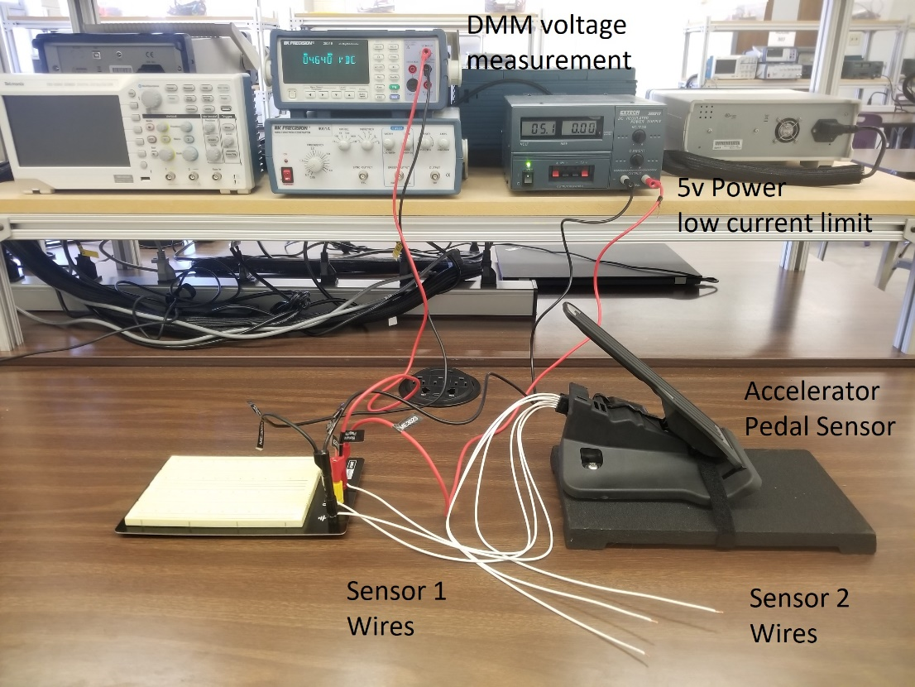

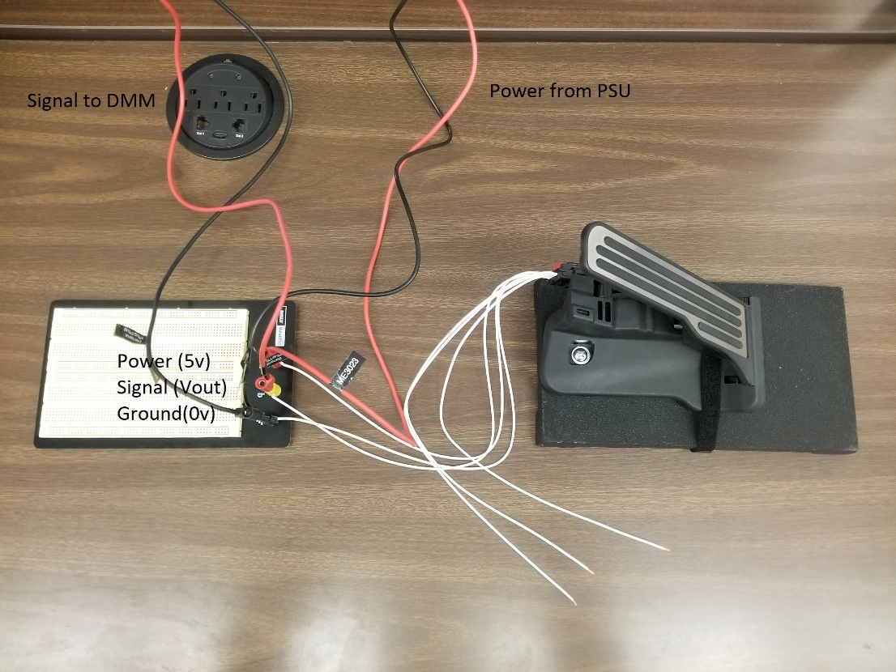

Figure 1 – Equipment Setup

Figure 2 – APP sensor wiring diagram (source: corvette forum)

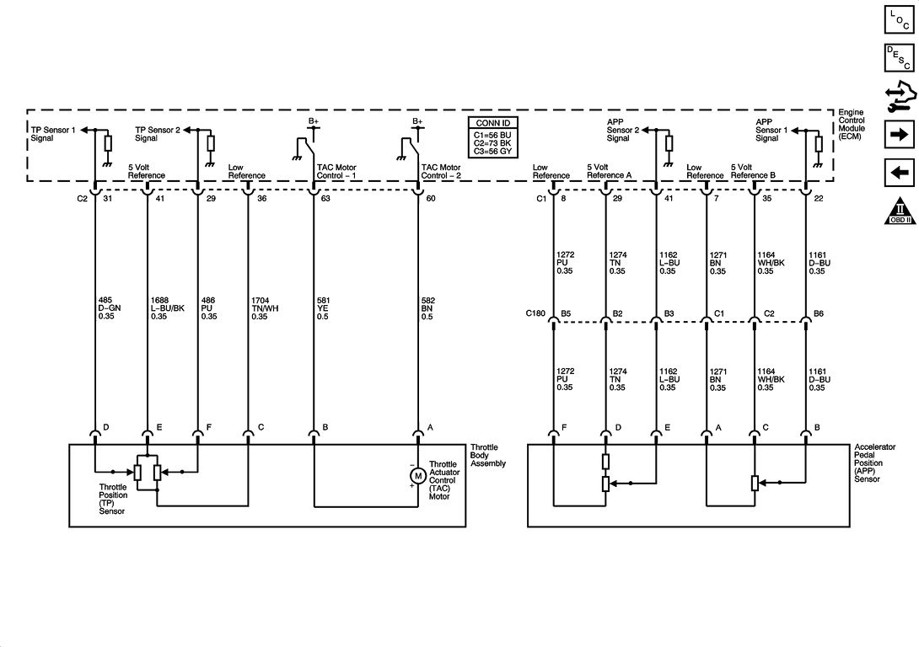Figure 3 – APP sensor connector pinout (source:

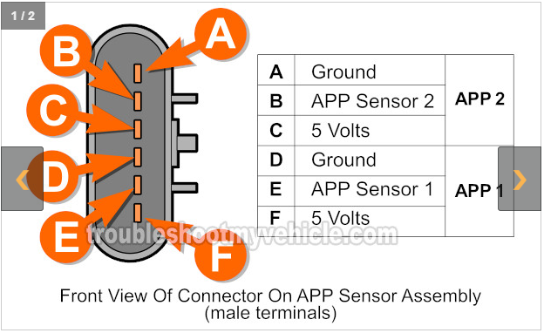

Document Bounty: 10 points for an wiring diagram with reference for GM P/N: 23418313